MATHEMATICS CRITICAL THINKING ABILITY MATERIALS SOCIAL ARRITHMATIC CLASS VII ASSISTED VIDEO ANIMATION IN THE ERA OF COVID-19

Mely Della Pratiwi, Ratu Ilma Indra Putri*,dan Zulkardi
Universitas Sriwijaya, Indonesia.

Article Info |  | ABSTRACT
Article history: |  | This study aims to determine students' mathematical critical thinking skills after the implementation of learning using PMRI and LSLC on social Arithmetic material with the help of animated videos in class VII. This type of research is descriptive. The subjects of this study were students of SMP Negeri 1 Palembang class VII.1, totaling 32 students. The data collection technique used is the provision of test questions which amount to 2 questions in the form of descriptions, observations and interviews. After doing the research, it was found that the mathematical critical thinking skills of class VII.1 students on social Arithmetic material, the subject of sales, purchases, profits, losses and percentages had appeared a lot, although there were still students who did not show indicators of their mathematical critical thinking abilities. The indicators that appear the most are the analytical indicators, while the indicators that appear the least are the interpretation indicators.
Keywords:
Mathematical critical thinking,
Social arithmetic,
PMRI,
LSLC,
Animated video
 |  | .
Corresponding Author :
Ratu Ilma Indra Putri
Department of Mathematics Education
Universitas Sriwijaya, Jl. Ogan, Ilir Bar. I, Palembang, South Sumatera 30139, Indonesia
Email : ratuilma@unsri.ac.id
How to Cite:
Pratiwi, M. D., Putri, R. I. I., & Zulkardi (2021). Mathematics Critical Thinking Ability Materials Social Arrithmatic Class VII Assisted Video Animation In The Era Of Covid-19. Infinity, X(X),XX-XX

- INTRODUCTION
One of the competencies for learning mathematics in Social Arithmetic material in the Minister of National Education of the Republic of Indonesia Number 22 of 2006 concerning content standards is to explain mathematical problems in everyday life. According to Rahmawati & Apsari (2018) Social Arithmetic is a mathematical science that discusses sales, purchases, profits, losses and percentages that are often encountered in everyday life. The importance of this subject as a knowledge base to solve problems that are often experienced. Although the subject looks easy, in reality it becomes a difficult subject and causes many problems (Malik, et al, 2013).
Ulandari, et al (2019) said that mathematics is a science that can train a person's way of thinking logically, critically and creatively. One of the competencies contained in Permendikbud Number 20 of 2016 is critical thinking skills. According to Widiantari, et al (2016), students' critical thinking skills are needed to understand and solve a problem they face by being able to analyze, evaluate, and interpret their own thinking for the better so as to allow errors in working on mathematical problems to be minimized.
However, the reality is that students' mathematical critical thinking skills are still low. In the research conducted by Pane (2019), the low mathematical critical thinking skills of students in the answers to practice questions given were unsatisfactory, students were unable to understand the problems indicated by writing down what was known and asked questions. appropriately. According to Sholihah and Mahmudi (2015) research, the low mathematical critical thinking ability of students in learning mathematics is motivated by teacher-centered learning, presentation of material that is not practice-oriented, learning resources are only from textbooks, there are no teaching materials that can help students. in solving problems. This type of learning is not interesting for students should start from what they understand (Ahmad, 2015).
From these facts, it is necessary for teachers to be able to create innovative learning, one of which is using a mathematics learning approach that is in accordance with the 2013 curriculum. The appropriate approach is the Indonesian Realistic Mathematics Education (PMRI) approach, because it has the potential to develop democratic, creative, and independent characters. students (Johar, et al, 2016). PMRI is one of the learning approaches carried out in the process of seeking knowledge that is relevant to real problems or everyday life, suitable as a starting point in learning Mathematics (Putri, 2015). Mathematics must be close to students and must be lived with everyday life. In PMRI, students should have the opportunity to rediscover mathematical ideas and concepts through various situations and practical problems under adult guidance (Fauziah, Putri et al. 2021). The following are some of the main principles of PMRI, namely guided discovery, mathematical discovery, educational phenomena and independent development models (Zulkardi & Putri, 2010). In addition, PMRI has 5 characteristics, namely using context, using various models, student contributions, interactivity and linkage (Zulkardi & Putri, 2010). The ability to think mathematically with the Indonesian Realistic Mathematics Education Approach (PMRI) is very much needed by students in solving a mathematical problem. So that the PMRI approach is suitable for use in mathematics learning to improve students' mathematical critical thinking skills.
This research is supported by using Lesson Study for Learning Community. Lesson study requires members to learn collaboratively with the aim that students are able to understand, exchange ideas, opinions and also discuss and build their own understanding well by collaborating with friends (Sato, 2014). Lesson Study can increase the effectiveness of student learning, the class becomes more effective and the teacher as a facilitator, so that learning becomes better (Yuanita, 2015).
Currently the world is being shocked by a global pandemic called Coronavirus disease (Covid-19) which causes learning to be carried out online or distance learning (Kuntarto, E. (2017). Distance learning (PJJ) is learning when students and teachers do not always face to face physically and simultaneously at school (Setiawan, 2020). According to Budiman (2017) the increasingly rapid development of information technology in the current era of globalization has an effect on the world of education. During the covid-19 period, one of the effective learning media that can used for distance learning, namely learning animation. The benefits of this animated video in the learning process are that it can improve students' critical thinking skills in the form of increasing abilities in terms of: focusing questions, analyzing, inducing and considering results, evaluating and giving reasons (Munandar & Taufik, 2018 ) In Arifin's research (2017) it can be concluded that learning with the help of animated videos can increase students' learning motivation and student attractiveness, so that learning can increase.
Based on this background, a study will be conducted that aims to determine students' mathematical critical thinking skills after being given PMRI and LSLC learning assisted by animated videos in the covid-19 era.
- METHOD
The type of research used is descriptive qualitative research. The subjects in this study were class VII.1 students of SMP Negeri 1 Palembang, totaling 32 students. Data collection techniques used are observation, giving test questions, and interviews. This research was carried out in accordance with the LSLC stages, namely Plan, Do, See and Re-design. Next, the step to analyze the data from the written test results is to determine the students' mathematical critical thinking skills. There are 6 indicators of mathematical critical thinking skills used in research as shown in the table below.
Table 1. Indicators and Descriptors of Mathematical Critical Thinking Ability
No | Indicators | Descriptors
1. | Interpretasi | Students can understand the problem by writing down what is known and what is asked of the problem correctly.
2. | Analisis | Learners can identify the relationships between the questions, concepts given in the problems shown by making mathematical formulas correctly and giving proper explanations.
3. | Evaluasi | Students can write problem solving.
4. | Inferensi | Students can draw conclusions from what is asked correctly
5. | Eksplanasi | Students can write down the final results and write down the reasons for the conclusions drawn.
6. | Self-regulation | Students can review written answers

To find out the emergence of indicators of students' mathematical critical thinking skills, it can be done by calculating the scores on each indicator of the questions given. The minimum score for each indicator is 0 and the maximum score for each indicator is 4. If the student gets a score of 4 from each indicator, the student can be said to have brought up indicators of mathematical critical thinking skills properly and correctly. If students get a score of 3 and 2, then the student can be said to have brought up his mathematical critical thinking skills but has not been maximized. However, if students get a score of 1 and 0 then it can be said that students are still not able to bring up their mathematical critical thinking skills.

- RESULTS AND DISCUSSION
This research was carried out on March 22, 2021 until mid-April 2021. This research was carried out according to the stages in the LSLC (Lesson study for learning community), namely Plan (planning stage), Do (implementation stage), See ( observation and reflection stage), and Re-design.
In the planning stage (plan) the researcher and the math teacher of SMP Negeri 1 Palembang collaborate and discuss to prepare several learning tools, such as lesson plans, LKPD sharing tasks and jumping tasks, as well as test questions to determine students' mathematical critical thinking skills. This plan phase activity involved 3 students of Sriwijaya University mathematics education and 2 mathematics teachers from SMP Negeri 1 Palembang. Then at the implementation stage (Do) learning activities are carried out 2 times, each meeting in 1 meeting is carried out within 2 x 30 minutes.
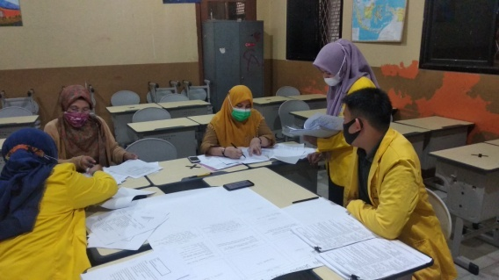
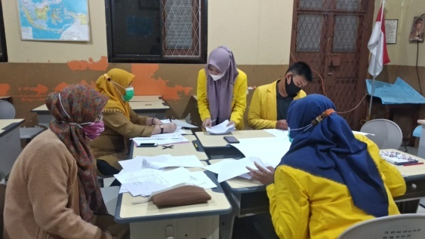

Figure 1. Planning stage process (Plan)
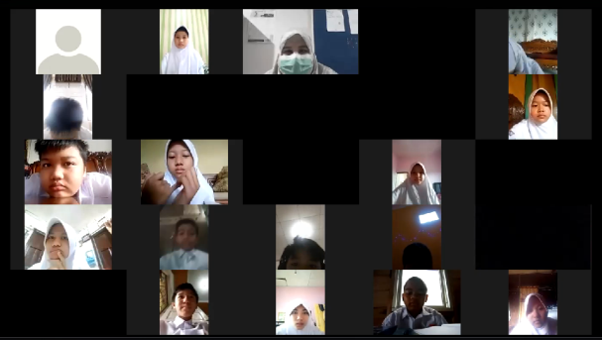
The first meeting was held on March 30, 2021 in class VII.1 through the Zoom Meeting application. The research subjects were divided into 8 groups where one group consisted of 3-4 students and the group consisted of students with low, medium and high abilities.

Figure 2. Online learning process through zoom meeting
At the implementation stage, learning activities are divided into 3 parts, namely Asynchronous (scheduled pre-study), synchronous (scheduled study), and Asynchronous (scheduled post-study). In the scheduled pre-learning learning process (Asynchronous) students will be given a video link containing an animated video of student learning on social arithmetic material with the subject of sales, purchases, profits, losses and percentages sent via whatsApp group, then the student can watch the learning video to complete and record any important things that have not been understood which will then be discussed together during the learning activities.
There are three learning activities implemented in the scheduled learning process (Syncronous), namely preliminary activities, core activities and closing activities. In the introductory activity, the teacher provides a zoom meeting link to students, then students can access it to join the class. Then the teacher opens the lesson by greeting, asking students' readiness to carry out learning activities, sending attendance, informing the learning objectives, and providing motivation to students. Then the teacher gives appreciation to the students and continues with the core activities. In the core activity there are several activities that must be done by students, namely working on LKPD sharing tasks and jumping tasks and test questions. When working on the LKPD students can write their answers on their respective sheets of paper and the teacher provides opportunities for students to have discussions with their group of friends through a breakout room at a zoom meeting. After completing the LKPD students are returned to one room. After all the students gathered, the teacher gave the opportunity for students to present their answers. If the students have presented their answers, then the teacher gives the students' mathematical critical thinking ability test questions that will be done by each student individually. Then the results of these answers can be sent via Google Classroom which the teacher has prepared. In the last asynchronous activity (scheduled post-study) the teacher made sure all students had collected the answers in google classroom.
At this stage of observation and reflection, teachers are asked to convey their impressions during teaching activities. Then the observer who served as an observer was asked to convey his findings during the learning activities and provide comments or suggestions. Comments or suggestions from the observer will be used by the teacher to redesign the next lesson so that learning activities can be better. At this stage of observation and reflection, observer group 2 said that there was one student who became the focus of observation, namely student A. In his observations, the observer focused on student A who was very confused and did not focus on working on the LKPD. Student A seemed to hold and scratch his head repeatedly. But student A is silent and does not ask his group friends for help.
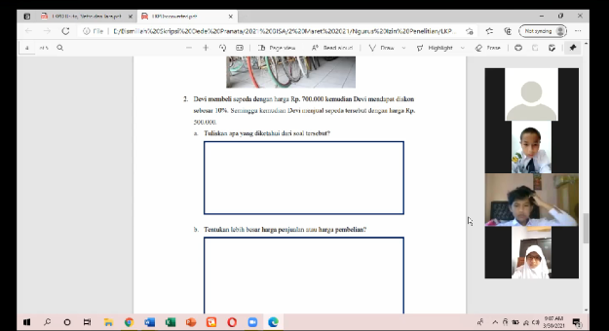

Figure 3. Student A is not focused
Initially, student A was not focused and felt confused. However, the group was very active in discussing so that one of his friends invited him to discuss and student A began to ask his group friends. The Re-Design stage was carried out to improve the design of the learning process and documentation. At this stage the teacher and other presenters agree again to improve the lesson plan or something else. The following is the result of the recapitulation of the students' mathematical critical thinking ability test questions.

Number of Eligible Students |  | Question Number
 |  | 1 | 2
Indicator | Writing down what is known (Interpretation) | 8 | 6
 | Writing formulas or concepts (Analysis) | 20 | 16
 | Write down the solution (Evaluation) | 19 | 17
 | Making conclusions (Inference) | 18 | 16
 | Write the final result correctly (Explanation) | 19 | 21
 | Reviewing the answers that have been written (Self-Regulation) | 12 | 15
Table 2. Recapitulation of the results of working on the mathematical critical thinking ability test questions

Question Number 1
SFA Students (high ability)
SFA students are one of the students who answer and write down the information in the problem and can solve the problem correctly and completely. When learning takes place, SFA students are also active participants.
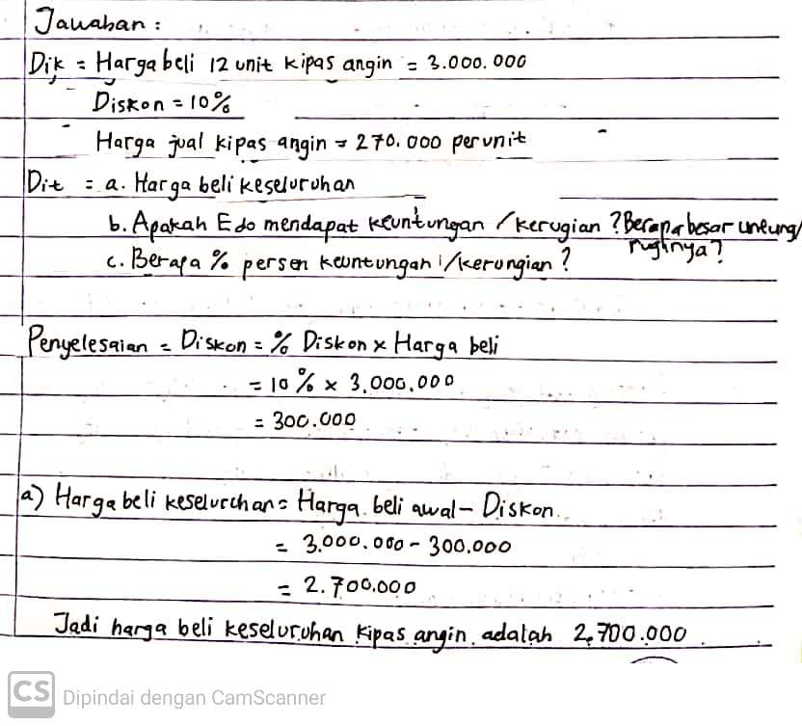
Students are able to write what is known correctly (Interpretation)

Students can analyze between concepts and questions correctly (Analysis)

Can write down the steps of completion correctly (Evaluation)
Inference, namely being able to write conclusions correctly
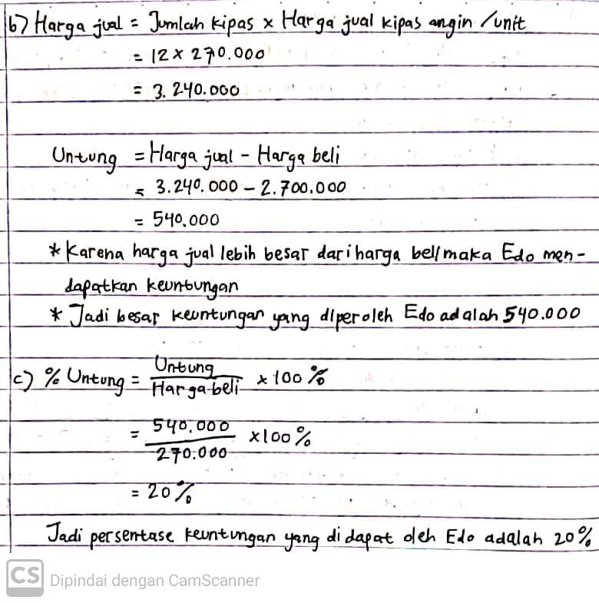

The final result correctly (explanation)

Inferensi

Evaluasi

Inferensi

Figure 4. Results of SFA students' answers

Based on the results of the students' answers above, SFA students are able to write answers according to the questions given in the questions. So that SFA students get a maximum score of 4 from each indicator. SFA students are able to bring up 6 indicators of students' mathematical critical thinking skills, namely in indicator 1, SFA students are able to write down information that is known and asked correctly, then indicator 2 is Analysis. SFA students can identify the relationships between the questions, concepts given in the problems shown. In indicator 3, namely evaluation, SFA students can write down the steps of completion correctly to get the appropriate final result. The 4th indicator is Inference, SFA students can write conclusions from the answers that have been completed. Then the 5th indicator, namely Explanation, SFA students are able to write the final results correctly. The 6th indicator of Self-Regulation is that students can review the answers they have written.
ALM Students (medium ability)
ALM students are one of the students who can solve problems and perform calculations correctly, but there are ALM students' answers that are still incomplete.
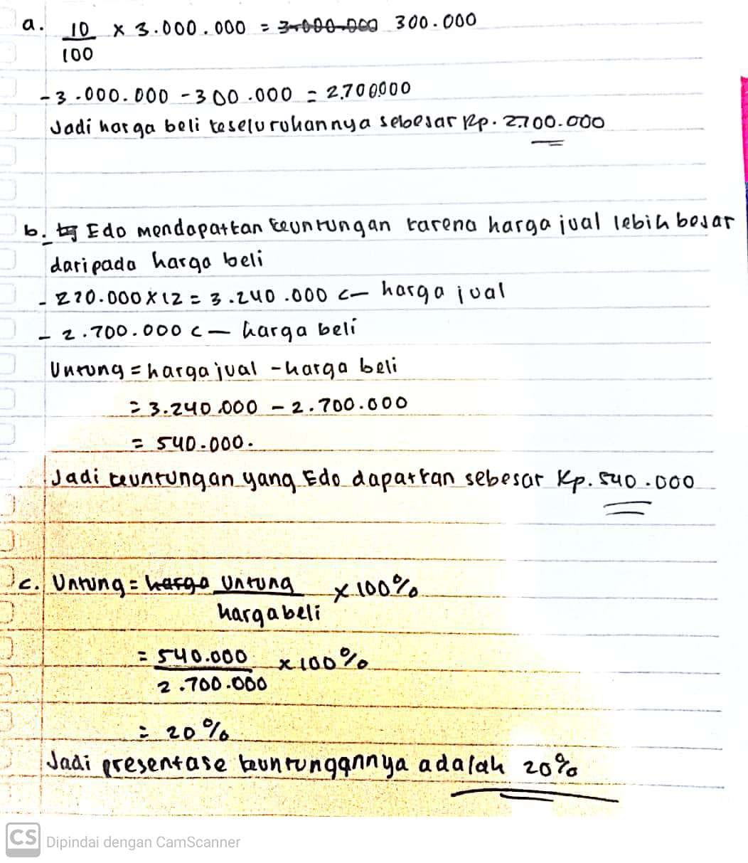
Evaluasi
Inferensi

Analisis

Eksplanasi
Inferensi
Figure 5. The results of ALM students' answers
ALM students have involved indicators of mathematical critical thinking skills but have not been maximized. Students do not write down information that is known from the problems given so that they get a score of 0 for this indicator. For other indicators, ALM participants are able to write and explain completely and precisely so that they get a score of 4.

LA Students (low ability)
LA students are one of the students who have not been precise and complete in solving the problems given. The following are answers from LA students.
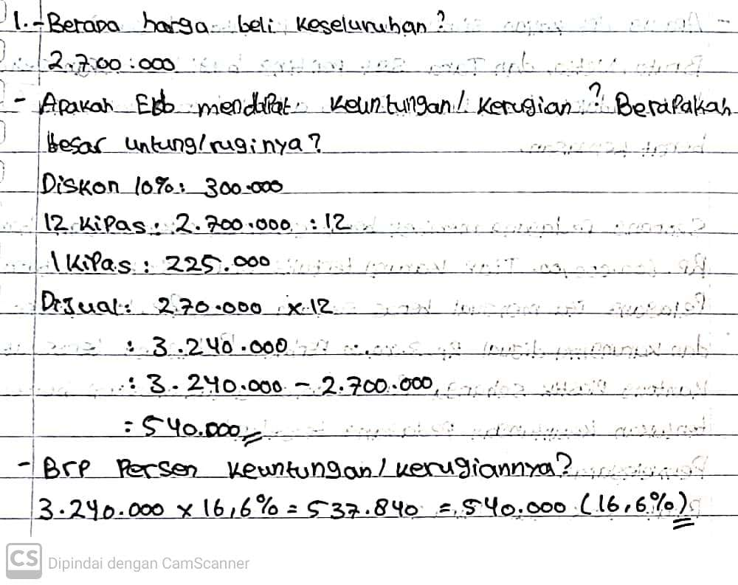
Don't write down the solution steps

Evaluasi

Not careful and make mistakes

Figure 6. Results of LA students' answers

From the answers of these students, LA students have not been able to meet all the indicators of students' mathematical critical thinking skills. The answers written by LA students are also still inaccurate, this is because students are less focused on working on the questions.

Question number 2.
In question number 2, there are a variety of student answers, there are student answers that identify the elements of the question and operate correctly, can identify the elements of the question but there are errors in performing calculations.

SFA students (high ability)
The following is the answer from one of the high-ability students on question no. 2
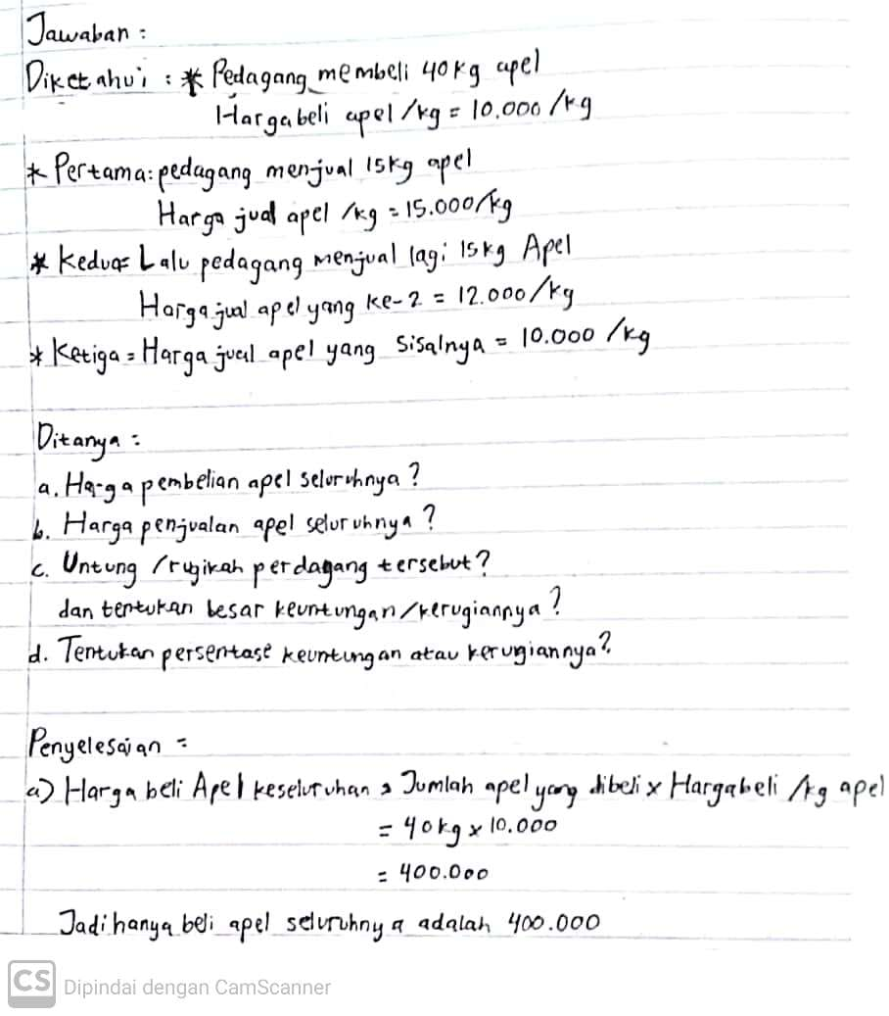

Students can write down information from the questions (Interpretasi)

Inferensi

Analisis

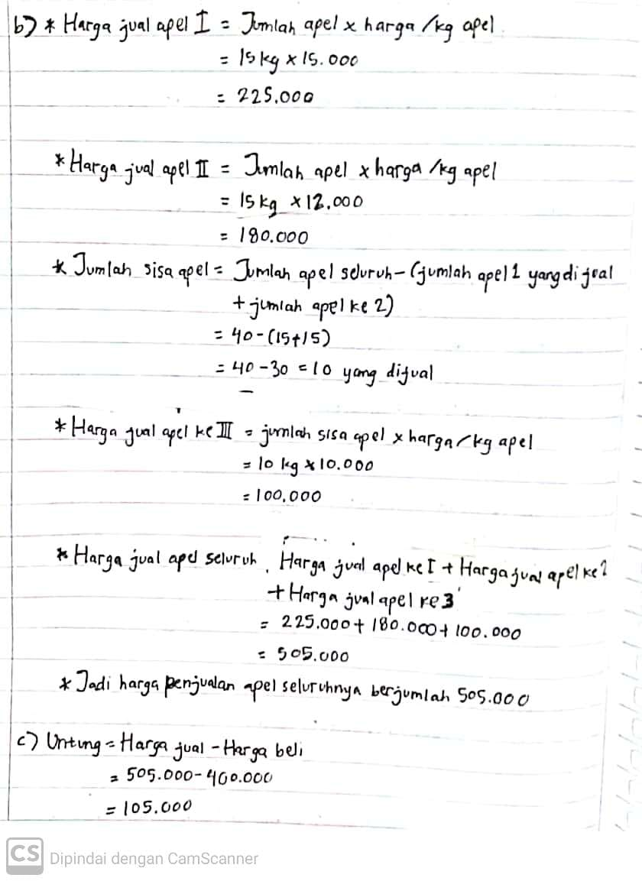

Students are able to write the final result correctly (explanation).

Evaluasi
Inferensi

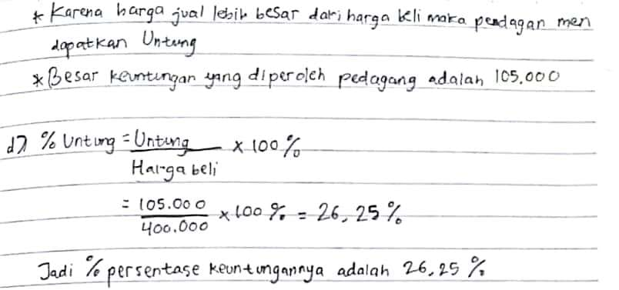
Inferensi

Evaluasi
Eksplanasi
Analisis
Inferensi

Figure 7. Answers of SFA students
From interviews that have been conducted, SFA students are able to write answers according to the questions given to the questions and indicators requested. So that SFA students get a maximum score of 4 from each indicator.

ALM students (medium ability)
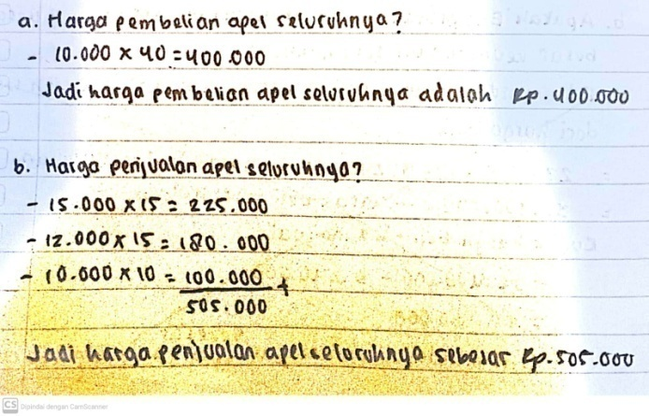
Making conclusions Students do not write formulas
Making
Conclusions
(inferensi)

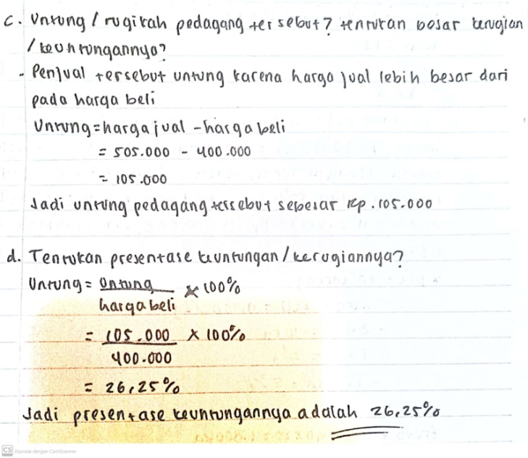

Analisis
Evaluasi
Inferensi

Evaluasi
Analisis
Eksplanasi
Inferensi

Figure 8. Answers of ALM students

From interviews that have been conducted, ALM students have been able to solve the problems given correctly and bring up indicators of critical thinking skills but are not complete. ALM students do not bring up all the indicators requested, as does the Interpretation indicator. ALM students do not write down what they know and are asked about from the problem, then at point b, ALM students do not show an Analysis indicator, that is, they do not write down formulas or concepts.

LA students (low ability)
The following is the answer from one of the low-ability students on question no. 2
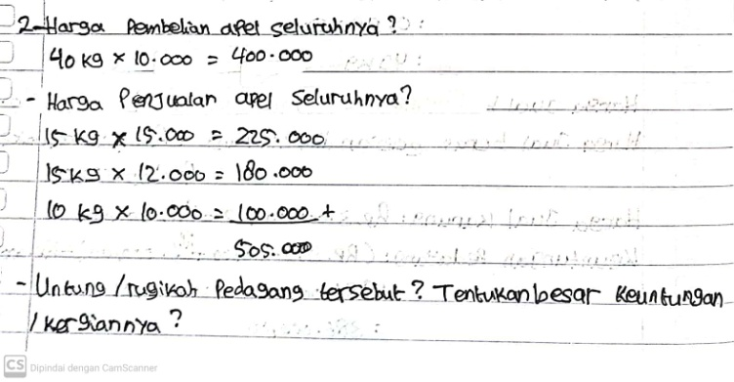
Do not write down the concept/formula
Not writing down known and asked information

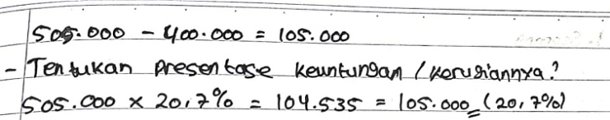
Miscalculation

Figure 9. Answers of LA students

LA students have been able to understand the problems given, but LA students have not been able to solve the problems given in accordance with the requested indicators. LA students do not write down the information asked so that they get a score of 0, then LA students do not write down formulas or concepts so that they get a score of 0, but students are able to make solutions to the problems given so that they get a score of 4.
The research that I did was a research on students' critical thinking mathematical abilities after learning using the PMRI and LSLC approaches on social Arithmetic material in class VII.1. The research data taken is from the results of the mathematical critical thinking ability test which was carried out at the evaluation of the second meeting. Two test questions given to students are mathematical critical thinking ability test questions that are compiled based on PMRI characteristics and indicators of mathematical critical thinking skills.
Indicators that appear a lot are analytical indicators (writing formulas or concepts). This indicator appears more often than other indicators. This is because students are quite good at analyzing questions, also because they have been trained in working on LKPD questions, sharing tasks and jumping tasks at the first meeting. Meanwhile, indicators that do not appear much are interpretation indicators (writing what is known). The appearance of this indicator is the least compared to other indicators. After conducting interviews with students, this happened because students were too focused on solving the problem to completion. Then considering the time given is not too much and not enough time to write it down.
Apart from the research that has been done the teacher's role here is to guide students so that students can solve problems with their knowledge. There is a PMRI principle called guided reinvention and has involved student contributions in completing, there is interaction between students and teachers in completing them (Zulkardi, 2002). From the results of student work, in activity 1 the teacher used LKPD which had been specially designed with PMRI characteristics. The learning process is carried out following the PMRI principles where students are guided to find concepts individually. (Putri & Zulkardi, 2018; Rahayu & Putri, 2018). This research is supported by using Lesson Study for Learning Community (LSLC), using the stages in the implementation of lesson study, namely Plan, Do, See, Re-design (Sato, 2014). Lesson Study can increase the effectiveness of student learning, the class becomes more effective and the teacher as a facilitator, so that learning becomes better (Yuanita, 2015).
From the research that has been done, it shows that after implementing learning with PMRI and LSLC using the help of animated learning videos, students' mathematical critical thinking skills are quite good. It can be seen from the number of students who succeeded in bringing up the requested indicators. Learning with PMRI and LSLC approaches using animated learning videos can indirectly guide students to develop and improve mathematical critical thinking skills. So that learning mathematics using the PMRI and LSLC approaches using the help of animated learning videos can be applied in schools.

- CONCLUSION
Based on the research that has been done, the results of research on mathematical critical thinking skills of class VII at SMP Negeri 1 Palembang through the PMRI and LSLC approaches assisted by animated videos in the covid-19 era, the mathematical critical thinking ability of class VII.1 students of SMP Negeri 1 Palembang on social arithmetic material has emerged, although not all achieve the maximum score.
The conclusion from the research that has been done is that the mathematical critical thinking ability of grade VII students through the PMRI and LSLC approaches on social arithmetic material assisted by animated videos is said to be quite good with several details as follows: the indicators that most often appear are analytical indicators, while the indicators that appear the least are namely the indicator of interpretation. The use of learning animation videos as learning media is very helpful for students in learning in the current covid-19 era, which requires students to learn from home online. To improve and develop students' mathematical critical thinking skills, teachers can apply PMRI learning and the LSLC system with the help of learning animation videos.

ACKNOWLEDGMENTS
This article is part of a research project funded by a professional grant from Sriwijaya University with the Rector's Decree number 0014/UN9/SK.LP2M.PT/2021 and research contract number 0127/UN9/SB3.LP2M.PT/2021

REFERENCES
Ahmad, H. (2015). Efektifitas pendekatan realistik dalam meningkatkan kemampuan penalaran matematik Peserta didik di Sekolah Menengah Atas Negeri 1 Tembilahan, Inhil, Riau. Jurnal unsyi
Arifin (2017). Penalaran Matematis Peserta didik Menggunakan Pendekatan Pmri Dan Lslc Pada Materi Pola Bilangan Di Kelas VIII
Fauziah, Putri dkk. (2021). Pembelajaran PMRI melalui Lesson Study. Palembang : Bening media publishing
Johar, R., Zubaidah, T., Mariana, N. (2016). Upaya guru mengembangkan karakter Peserta didik melalui pembelajaran matematika dengan pendekatan realistic pada materi perkalian. Jurnal Pendidikan Matematika Sriwijaya. 10(1) : 96-113
Kuntarto, E. (2017). Keefektifan Model Pembelajaran Daring dalam Perkuliahan Bahasa Indonesiadi Perguruan Tinggi.Indonesian Language Education and Literature,3(1),99-11
Malik, dkk. (2013). Pengembangan Perangkat Pembelajaran Aritmatika Sosial Berbasis Problem Based Learning Di Kelas Vii. Jurnal Elemen Vol. 2 No. 2, Juli 2016, hal. 92 – 115
Pane (2019). Efektivitas Pendekatan Open-Ended Terhadap Kemampuan Berpikir Kritis Matematis Peserta didik Di Man Tapanuli Selatan. JURNAL MathEdu (Mathematic Education Journal) Vol. 2. Diakses pada 2 Juli 2019
Permendikbud (2016). Peraturan Menteri Pendidikan Dan Kebudayaan Nomor 20 Tahun 2016 Tentang Standar Kompetensi Lulusan Pendidikan Dasar Dan Menengah
Putri, R.I.I. (2015). Pengaruh Interaksi Pendekatan Pembelajaran Dan Bentuk Tes Formatif Terhadap Hasil Belajar Matematika. Jurnal Pendidikan Dan Pembelajaran, 22(1), 69-75.
Putri, R.I.I., & Zulkardi. (2018). Noticing students thinking and quality of interactivity during mathematics learning. Proceedings of First Indonesian Communication Forum of Teacher Training and Education Faculty Leaders International Conference on Education 2017 (ICE 2017)
Rahayu, A.P., & Putri, R.I.I. (2018). Learning process of decimals through the base ten strips at the fifth grade. International Journal of Instruction.
Rahmawati & Apsari (2018). Analisis Kemampuan Pemecahan Masalah Aritmatika Sosial Pada Peserta didik Sdn No.05 Suruh Tembawang (Perbatasan Indonesia-Malaysia). Jurnal Pendidikan Informatika dan Sains. Vol.7, No. 2, Desember 2018
Sato (2014). Implementasi Lesson Study Dalam Pembelajaran Matematika Materi Perkalian Dan Pembagian Bilangan Bulat Peserta Didik Kelas VII. Seminar dan Lokakarya 2018, Universitas Ahmad Dahlan
Sholihah Dan Mahmudi (2015). Keefektifan Experiential Learning Pembelajaran Matematika Mts Materi Bangun Ruang Sisi Datar. Jurnal pendidikan matematika, online ISSN : 2477-1503
Setiawan (2020). Lembar Kegiatan Literasi Saintifik untuk Pembelajaran Jarak Jauh Topik Penyakit Coronavirus 2019 (COVID-19). Jurnal Ilmu Pendidikan. Volume 2 Nomor 1 April 2020 Halaman 28 – 37
Ulandari, dkk (2019). Penerapan Pendekatan Saintifik Berbantuan Geogebra dalam Upaya Meningkatkan Pemahaman Konsep Matematis Peserta didik. Jurnal Matematika dan Pendidikan Matematika Vol. 10, No. 2, Desember 2019
Widiantari, Suarjana & Kusmariyatni (2016). Analisis Kemampuan Berpikir Kritis Peserta didik Kelas Iv Dalam Pembelajaran Matematika. Journal PGSD Universitas Pendidikan Ganesha. Vol: 4 No: 1 Tahun: 2016
Yuanita. (2015). Presentasi Matematika Peserta didik Pada Penerapan Pendekatan Matematika Realistic Dalam Pelaksanaan Lesson Study Di Sekolah Menengah Pertama. Disajikan dalam 7th International Seminar on Regional Education, 2, 973-980
Zulkardi. (2002). Developing A Learning Environment on Realistic Mathematics Education for Indonesian Student Teacher. Doctoral Dissertation. Enschede: University of Twente.

